Name: ………………………………………………………………..

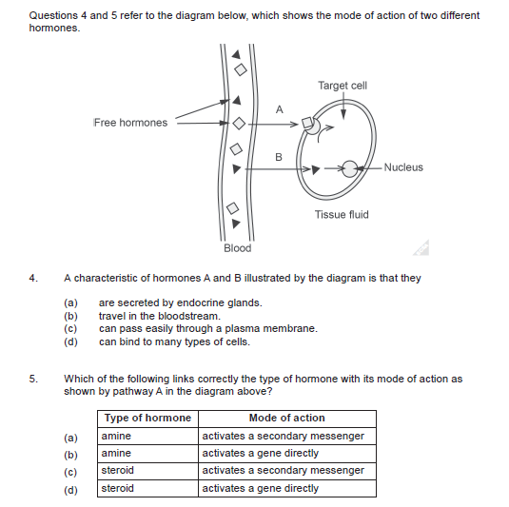

**Question 31 (8 marks)**

The endocrine system produces a variety of hormones, including the sex hormones, such as testosterone and oestrogen. These are examples of lipid-soluble hormones. Consider each of the following mechanisms of hormone action.

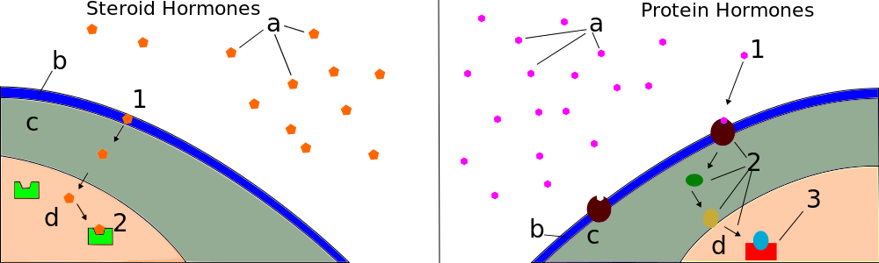

Model A Model B

1. State the model, A or B, that best corresponds to the mechanism of lipid-soluble hormones (1 mark)

___________

1. State why Model B would result in short-lived responses. (1 mark)

______________________________________________________________________________________________________________________________________________________________

1. Hormones elicit responses via different mechanisms. State **two (2)** ways in which hormones exhibit their effects. (2 marks)

_____________________________________________________________________________________________________________________________________________________________________________________________________________________________________________

